Senior Seminar (COSC-4272)
Assessment of Lesson 6

Exercise 1. What are the most expected errors in English documents? Give examples.

- Run-on sentences are very much an expected error in English documents as they keep going on and on and sometimes you lose track of what the sentence is trying to say, oh, and this is most definitely an example of a run-on sentences because it doesn’t stop and the sentence started and ended in what feels like two very different locations, which are terrible in an English document.
- Subject-verb and pronoun-noun agreement is expected in English documents they is very obvious and they have confusing the reader on the quantity or relationship between the verb or noun and the subject or pronoun across the English document.
- Finally, overuse of a word or phrase, such as “English document”, does not violate any grammatical rules, but annoys the reader more.
(I hope that it is evident that each point showed the example as the error in itself).

Exercise 2. Why it is important to split long sentences? Give examples.

- Long sentences are hard to track in terms of subject and focus. It is better to split long sentences into easier portions to understand rather than cram everything in at once.
- Ex: “As he crossed toward the pharmacy at the corner he involuntarily turned his head because of a burst of light that had ricocheted from his temple, and saw, with that quick smile with which we greet a rainbow or a rose, a blindingly white parallelogram of sky being unloaded from the van—a dresser with mirrors across which, as across a cinema screen, passed a flawlessly clear reflection of boughs sliding and swaying not arboreally, but with a human vacillation, produced by the nature of those who were carrying this sky, these boughs, this gliding façade” (Vladimir Nabokov, “The Gift.” 96 words).

Exercise 3. Why do you think graphical images are important in documents? Do you agree to have a document made up only of images, with no text whatsoever? Give reasons.

- Graphical images are important as they turn a boring document into something with a little more life. They allow the reader to visualize results, see the content described in the paper in a more graphical way, or may give a break in reading to allow the reader’s eyes to track better.
- I believe that having a document solely of images and void of text would not be useful, though it majorly depends on the context. It is hard, academically, to prove and make a point using only images, so in that sense, images are not the final form of educational content, but rather a complementary material to help digest large quantities of information.

Exercise 4. Why in many documents the ‘good’ news are larger font than the not so pleasant news? Give examples.

- On the contrary, most common in news stories is not pleasant news first in bold text, and supplementary good news following in ordinary font and space. This follows with the old adage: “If it bleeds, it leads”.
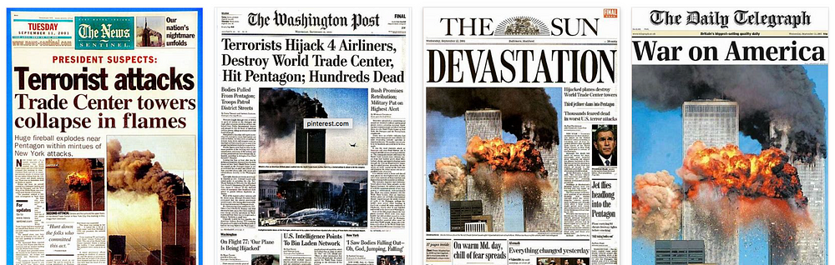
- This view is utilized by major companies as it attracts readers and keeps them hooked enough to buy the news and continue coming back for more unpleasant news.

Exercise 5. What are the word processor fundamentals? Give examples.

- Word processor fundamentals includes these specific parts:
  - Font and font format
  - Font Size
  - Page Attributes
    - Page Orientation (Page 1 & 2 are portrait, page 3 is landscape).
    - Margins (all are set to 1’)
    - Columns (the columns are set to 2)
    - Page numbering (all pages are numbered)
  - Line Spacing (set to 1.5)
  - Graphics (shown on Exercise 4).

